

**COMPUTER NETWORKS**

**ASSIGNMENT 02**

**Group Members:**

i) Bilal Ahmed Khan (20k0183)

ii) Muaaz Alam (20k0212)

**Task:**

Develop a web proxy server with the following features

1. HTTP communications between client and server.

2. HTTPs communications between client and server.

3. Caching of popular content using at least two scheduling algorithms.

4. Content filtering (filtering rules should be configurable via admin console).

**Solution:**

1. **Http communication:**

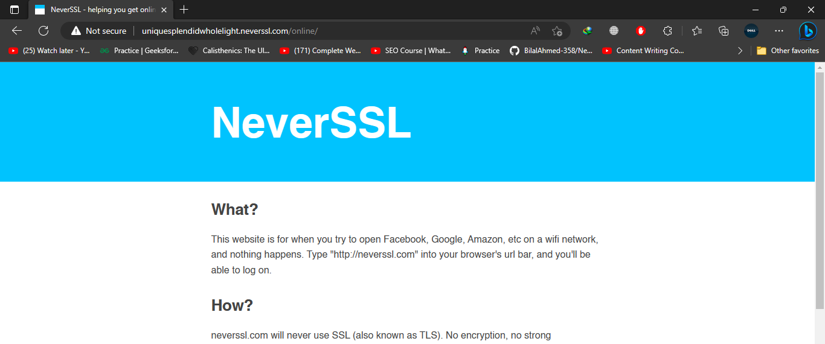

**ii) Https Communication:**



1. **Caching using two scheduling algorithms:**

We implemented two scheduling algorithms

1. FIFO

def fifo_cache_scheduling():

    entries = os.listdir(

        r"C:\Users\Bilal\Desktop\Compute Networks Assignment 02\cache")

    current_time = time.ctime()

    path = Path(r"C:\Users\Bilal\Desktop\Compute Networks Assignment 02\cache")

    for entry in entries:

        filePath = Path.joinpath(path, entry)

        creation_time = os.path.getctime(filePath)

        creation_datetime = datetime.datetime.fromtimestamp(creation_time)

        current_datetime = datetime.datetime.now()

        days_since_accessed = (current_datetime - creation_datetime).days

        if days_since_accessed > 7:

            os.remove(filePath)

            print(str(filePath) + "Deleted due cache expiration.")

1. Least Recently Used

def LeastRecentlyUsedScheduling():

    entries = os.listdir(

        r"C:\Users\Bilal\Desktop\Compute Networks Assignment 02\cache")

    current_time = time.ctime()

    path = Path(r"C:\Users\Bilal\Desktop\Compute Networks Assignment 02\cache")

    for entry in entries:

        filePath = Path.joinpath(path, entry)

        last_accessed_time = os.path.getatime(filePath)

        creation_datetime = datetime.datetime.fromtimestamp(last_accessed_time)

        current_datetime = datetime.datetime.now()

        days_since_accessed = (current_datetime - creation_datetime).days

        if days_since_accessed > 7:

            os.remove(filePath)

            print(str(filePath) + "Deleted due cache expiration.")

Items being fetched from cache shown on server command line

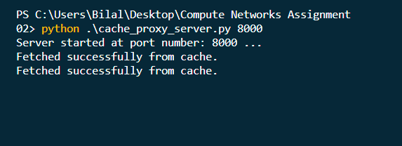

Cache folder holding cached files

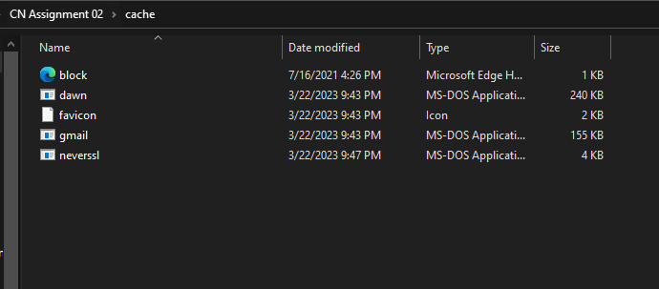

1. **Content filtering:**

Entering the names of the websites to be blocked

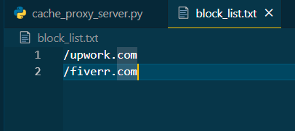

Verification from browser

